**HyperTED**

In 1984, the global set of conferences called TED started to organize talks under the slogan: "*Ideas Worth Spreading*”. In 1990, when the first annual event was held, the only way to enjoy those talks was to buy the corresponding tickets and to physically attend the event.

In 2006, TED talks started to be offered online at TED.com. They became viewable for any person wherever his location and without needing to pay an entrance fee.

2014 marks a new turning point in the story of TED through the launch of HyperTED. While a entire talk has a value as an editorial but isolated piece of media, we wanted to explore how TED talks could also be consumed and interlinked at the fragment level, pushing further the concept of hypervideo[1]. HyperTED offers such a unique and innovative way of exploring over 1681 TED talks at the fragment level, opening a window to a more effective and efficient dissemination of the knowledge present in those inspirational conferences.



In this application, the concept of complete video talk as a first class citizen is further refined through the notion of chapters. Similar to paragraphs in a textual document, chapters delimit particular ideas that sequentially illustrate the context of the video. Viewers often fast browse a video without necessarily watch entirely each particular chapter. HyperTED tackles this problem by proposing a set of automatically annotated media fragments called Hot Spots which intend to highlight the main concepts and topics discussed in a video talk. A dedicated interface eases the exploration and sharing of those Hot Spots.

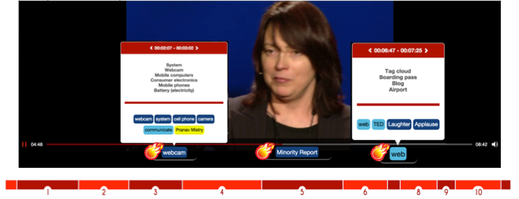

Such a closed collection of high quality video material could finally benefit from being better interlinked at the fragment level, going way beyond the current top 3 talks that the official TED site is recommending watching at the end of each talk. HyperTED offers this functionality and recommends links between fragments of TED talks based on the topics found by our Hot Spots detector.

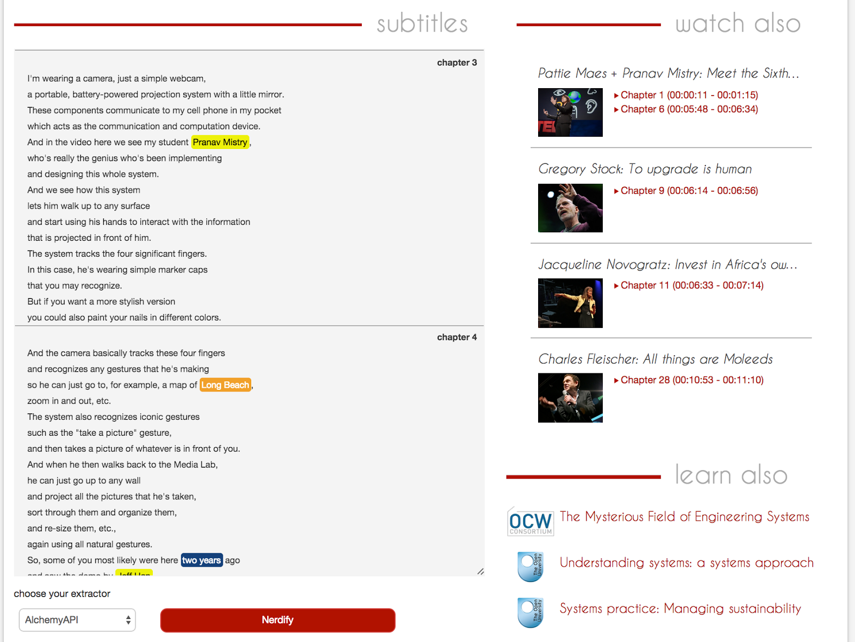

In addition, Hot Spots are used as anchors for finding related educational resources where the user can learn more about what the video is talking about, such as MOOCs, video lectures and online tutorials.

In summary, the finer level of granularity that HyperTED provides via its innovative player allows users to go back and forth, to share and to relive particular fragments they liked or simply found interesting. In the same way a professor highlight the important parts of a lesson when trying to explain it, HyperTED emphasizes some important parts of a video and their corresponding concepts and topics. Previewing what are the important topics a video illustrates makes viewers’ life easier. The video content is enriched with background knowledge from DBpedia or Freebase, and online educational resources from catalogs provided by [the Open University](http://www.open.ac.uk/) and [Open Courseware](http://ocw.mit.edu/).

1. <http://en.wikipedia.org/wiki/Hypervideo>